
OPC Unified Architecture
Specification
Part 1: Overview and Concepts
Release Candidate 1.01.03
March 6, 2008

Specification Type: | Industry Standard Specification | Comments: | Report or view errata: http://www.opcfoundation.org/errata
Title: | OPC Unified Architecture  Part 1 :Overview and Concepts | Date: | March 6, 2008
Version: | Release Candidate 1.01.03 | Software: | MS-Word
 |  | Source: | 0000.doc
Author: | OPC Foundation | Status: | Release Candidate

CONTENTS
Page

FOREWORD vi
AGREEMENT OF USE vi
1 Scope 1
2 Reference documents 1
3 Terms, definitions, and abbreviations 1
3.1 OPC UA terms 1
3.1.1 AddressSpace 1
3.1.2 Alarm 2
3.1.3 Attribute 2
3.1.4 Certificate 2
3.1.5 Client 2
3.1.6 Condition 2
3.1.7 Communication Stack 2
3.1.8 Complex Data 2
3.1.9 Discovery 2
3.1.10 Event 2
3.1.11 EventNotifier 2
3.1.12 Information Model 2
3.1.13 Message 3
3.1.14 Method 3
3.1.15 MonitoredItem 3
3.1.16 Node 3
3.1.17 NodeClass 3
3.1.18 Notification 3
3.1.19 NotificationMessage 3
3.1.20 Object 3
3.1.21 Object Instance 3
3.1.22 ObjectType 3
3.1.23 Profile 3
3.1.24 Program 4
3.1.25 Reference 4
3.1.26 ReferenceType 4
3.1.27 RootNode 4
3.1.28 Server 4
3.1.29 Service 4
3.1.30 Service Set 4
3.1.31 Session 4
3.1.32 Subscription 4
3.1.33 Variable 4
3.1.34 View 5
3.2 Abbreviations and symbols 5
4 Structure of the OPC UA series 5
4.1 Specification Organization 5
4.2 Core Specification Parts 6
4.3 Access Type Specification Parts 6
5 Overview 7
5.1 UA Scope 7
5.2 Introduction 7
5.3 Design goals 7
5.4 Integrated models and services 9
5.4.1 Security model 9
5.4.2 Integrated AddressSpace model 10
5.4.3 Integrated object model 10
5.4.4 Integrated services 10
5.5 Sessions 11
5.6 Redundancy 11
6 Systems concepts 11
6.1 Overview 11
6.2 OPC UA Clients 12
6.3 OPC UA Servers 12
6.3.1 Real objects 13
6.3.2 OPC UA Server application 13
6.3.3 OPC UA AddressSpace 13
6.3.4 Publisher/subscriber entities 14
6.3.5 OPC UA Service Interface 14
6.3.6 Server to Server interactions 14
7 Service Sets 16
7.1 General 16
7.2 Discovery Service Set 16
7.3 SecureChannel Service Set 16
7.4 Session Service Set 17
7.5 NodeManagement Service Set 17
7.6 View Service Set 17
7.7 Query Service Set 17
7.8 Attribute Service Set 17
7.9 Method Service Set 18
7.10 MonitoredItem Service Set 18
7.11 Subscription Service Set 18

Figures
Figure 1 – OPC UA Specification Organization 5
Figure 2 – OPC UA Target Applications 8
Figure 3 – OPC UA System Architecture 11
Figure 4 – OPC UA Client Architecture 12
Figure 5 – OPC UA Server Architecture 13
Figure 6 – Peer-to-peer interactions between Servers 15
Figure 7 – Chained Server Example 15
Figure 8 – SecureChannel and Session Services 17

OPC Foundation
____________

UNIFIED ARCHITECTURE –
FOREWORD
This specification is the specification for developers of OPC UA applications. The specification is a result of an analysis and design process to develop a standard interface to facilitate the development of applications by multiple vendors that shall inter-operate seamlessly together.
Copyright © 2006-2008, OPC Foundation, Inc.
AGREEMENT OF USE
COPYRIGHT RESTRICTIONS
Any unauthorized use of this specification may violate copyright laws, trademark laws, and communications regulations and statutes. This document contains information which is protected by copyright. All Rights Reserved. No part of this work covered by copyright herein may be reproduced or used in any form or by any means--graphic, electronic, or mechanical, including photocopying, recording, taping, or information storage and retrieval systems--without permission of the copyright owner.
OPC Foundation members and non-members are prohibited from copying and redistributing this specification. All copies must be obtained on an individual basis, directly from the OPC Foundation Web site
http://www.opcfoundation.org.
PATENTS
The attention of adopters is directed to the possibility that compliance with or adoption of OPC specifications may require use of an invention covered by patent rights. OPC shall not be responsible for identifying patents for which a license may be required by any OPC specification, or for conducting legal inquiries into the legal validity or scope of those patents that are brought to its attention. OPC specifications are prospective and advisory only. Prospective users are responsible for protecting themselves against liability for infringement of patents.
WARRANTY AND LIABILITY DISCLAIMERS
WHILE THIS PUBLICATION IS BELIEVED TO BE ACCURATE, IT IS PROVIDED "AS IS" AND MAY CONTAIN ERRORS OR MISPRINTS. THE OPC FOUDATION MAKES NO WARRANTY OF ANY KIND, EXPRESSED OR IMPLIED, WITH REGARD TO THIS PUBLICATION, INCLUDING BUT NOT LIMITED TO ANY WARRANTY OF TITLE OR OWNERSHIP, IMPLIED WARRANTY OF MERCHANTABILITY OR WARRANTY OF FITNESS FOR A PARTICULAR PURPOSE OR USE. IN NO EVENT SHALL THE OPC FOUNDATION BE LIABLE FOR ERRORS CONTAINED HEREIN OR FOR DIRECT, INDIRECT, INCIDENTAL, SPECIAL, CONSEQUENTIAL, RELIANCE OR COVER DAMAGES, INCLUDING LOSS OF PROFITS, REVENUE, DATA OR USE, INCURRED BY ANY USER OR ANY THIRD PARTY IN CONNECTION WITH THE FURNISHING, PERFORMANCE, OR USE OF THIS MATERIAL, EVEN IF ADVISED OF THE POSSIBILITY OF SUCH DAMAGES.
The entire risk as to the quality and performance of software developed using this specification is borne by you.
RESTRICTED RIGHTS LEGEND
This Specification is provided with Restricted Rights. Use, duplication or disclosure by the U.S. government is subject to restrictions as set forth in (a) this Agreement pursuant to DFARs 227.7202-3(a); (b) subparagraph (c)(1)(i) of the Rights in Technical Data and Computer Software clause at DFARs 252.227-7013; or (c) the Commercial Computer Software Restricted Rights clause at FAR 52.227-19 subdivision (c)(1) and (2), as applicable. Contractor / manufacturer are the OPC Foundation,. 16101 N. 82nd Street, Suite 3B, Scottsdale, AZ, 85260-1830
COMPLIANCE
The OPC Foundation shall at all times be the sole entity that may authorize developers, suppliers and sellers of hardware and software to use certification marks, trademarks or other special designations to indicate compliance with these materials. Products developed using this specification may claim compliance or conformance with this specification if and only if the software satisfactorily meets the certification requirements set by the OPC Foundation. Products that do not meet these requirements may claim only that the product was based on this specification and must not claim compliance or conformance with this specification.
Trademarks
Most computer and software brand names have trademarks or registered trademarks. The individual trademarks have not been listed here.
GENERAL PROVISIONS
Should any provision of this Agreement be held to be void, invalid, unenforceable or illegal by a court, the validity and enforceability of the other provisions shall not be affected thereby.
This Agreement shall be governed by and construed under the laws of the State of Minnesota, excluding its choice or law rules.
This Agreement embodies the entire understanding between the parties with respect to, and supersedes any prior understanding or agreement (oral or written) relating to, this specification.
ISSUE REPORTING
The OPC Foundation strives to maintain the highest quality standards for its published specifications, hence they undergo constant review and refinement. Readers are encouraged to report any issues and view any existing errata here:
http://www.opcfoundation.org/errata

Scope
Part 1 presents the concepts and overview of the OPC Unified Architecture (OPC UA). Reading this document is helpful to understand the remaining Parts of this multi-part document set. Each of the other parts is briefly explained along with a suggested reading order. This Part is non-normative.

Reference documents
The OPC UA Specification is organized as a multi-part document. While describing the concepts, this part will refer to these parts of the specification:
Part 2: OPC UA Specification: Part 2 – Security Model, Version 1.0 or later
http://www.opcfoundation.org/UA/Part2/
Part 3: OPC UA Specification: Part 3 – Address Space Model, Version 1.0 or later
http://www.opcfoundation.org/UA/Part3/
Part 4: OPC UA Specification: Part 4 – Services, Version 1.0 or later
http://www.opcfoundation.org/UA/Part4/
Part 5: OPC UA Specification: Part 5 – Information Model, Version 1.0 or later
http://www.opcfoundation.org/UA/Part5/
Part 6: OPC UA Specification: Part 6 – Mappings, Version 1.0 or later
http://www.opcfoundation.org/UA/Part6/
Part 7: OPC UA Specification: Part 7 – Profiles, Version 1.0 or later
http://www.opcfoundation.org/UA/Part7/
Part 8: OPC UA Specification: Part 8 – Data Access, Version 1.0 or later
http://www.opcfoundation.org/UA/Part8/
Part 9: OPC UA Specification: Part 9 – Alarms and Conditions, Version 1.0 or later
http://www.opcfoundation.org/UA/Part9/
Part 10: OPC UA Specification: Part 10 – Programs, Version 1.0 or later
http://www.opcfoundation.org/UA/Part10/
Part 11: OPC UA Specification: Part 11 – Historical Access, Version 1.0 or later
http://www.opcfoundation.org/UA/Part11/
Part 12: OPC UA Specification: Part 12 – Discovery, Version 1.0 or later
http://www.opcfoundation.org/UA/Part12/

Terms, definitions, and abbreviations
For the purposes of this specification, the following definitions apply.

OPC UA terms

AddressSpace
The collection of information that an OPC UA Server makes visible to its Clients. See Part 3: for a description of the contents and structure of the Server AddressSpace.

Alarm
A type of Event associated with a state condition that typically requires acknowledgement. See Part 9: for a description of Alarms.

Attribute
A primitive characteristic of a Node. All Attributes are defined by OPC UA, and may not be defined by Clients or Servers. Attributes are the only elements in the AddressSpace permitted to have data values.

Certificate
A digitally signed data structure that describes capabilities of a Client or Server.

Client
A software application that sends Messages to OPC UA Servers conforming to the Services specified in this set of specifications.

Condition
A generic term that is an extension to an Event. A Condition represents the conditions of a system or one of its components and always exists in some state.

Communication Stack
A layered set of software modules between the application and the hardware that provides various functions to encode, encrypt and format a Message for sending, and to decode, decrypt and unpack a Message that was received.

Complex Data
Data that is composed of elements or more than one primitive data type, such as a structure.

Discovery
The process by which OPC UA Client obtain information about OPC UA Servers, including endpoint and security information.

Event
A generic term used to describe an occurrence of some significance within a system or system component.

EventNotifier
A special Attribute of a Node that signifies that a Client may subscribe to that particular Node to receive Notifications of Event occurrences.

Information Model
An organizational framework that defines, characterizes and relates information resources of a given system or set of systems. The core address space model supports the representation of Information Models in the AddressSpace. See Part 5: for a description of the base OPC UA Information Model.

Message
The data unit conveyed between Client and Server that represents a specific Service request or response.

Method
A callable software function.

MonitoredItem
A Client-defined entity in the Server used to monitor Attributes or EventNotifiers for new values or Event occurrences and generate Notifications for them.

Node
The fundamental component of an AddressSpace.

NodeClass
The class of a Node in an AddressSpace. NodeClasses define the metadata for the components of the OPC UA Object Model. They also define constructs, such as Views, that are used to organize the AddressSpace.

Notification
The generic term for data that announces the detection of an Event or of a changed Attribute value. Notifications are sent in NotificationMessages.

NotificationMessage
A Message published from a Subscription that contains one or more Notifications.

Object
A Node that represents a physical or abstract element of a system. Objects are modelled using the OPC UA Object Model. Systems, subsystems and devices are examples of Objects. An Object may be defined as an instance of an ObjectType.

Object Instance
A synonym for Object. Not all Objects are defined by ObjectTypes.

ObjectType
A Node that represents the type definition for an Object.

Profile
A specific set of capabilities, defined in Part 7:, to which a Server may claim conformance. Each Server may claim conformance to more than one Profile.

Program
An executable Object that, when invoked, immediately returns a response to indicate that execution has started, and then returns intermediate and final results through Subscriptions identified by the Client during invocation.

Reference
An explicit relationship (a named pointer) from one Node to another. The Node that contains the Reference is the source Node, and the referenced Node is the target Node. All References are defined by ReferenceTypes.

ReferenceType
A Node that represents the type definition of a Reference. The ReferenceType specifies the semantics of a Reference. The name of a ReferenceType identifies how source Nodes are related to target Nodes and generally reflects an operation between the two, such as “A Contains B”.

RootNode
The beginning or top Node of a hierarchy. The RootNode of the OPC UA AddressSpace is defined in Part 5:.

Server
A software application that implements and exposes the Services specified in this set of specifications.

Service
A Client-callable operation in an OPC UA Server. Services are defined in Part 4:. A Service is similar to a method call in a programming language or an operation in a Web services WSDL contract.

Service Set
A group of related Services.

Session
A logical long-running connection between a Client and a Server. A Session maintains state information between Service calls from the Client to the Server.

Subscription
A Client-defined endpoint in the Server, used to return Notifications to the Client. Generic term that describes a set of Nodes selected by the Client (1) that the Server periodically monitors for the existence of some condition, and (2) for which the Server sends Notifications to the Client when the condition is detected.

Variable
A Variable is a Node that contains a value.

View
A specific subset of the AddressSpace that is of interest to the Client.

Abbreviations and symbols
A&E Alarms and Events
API Application Programming Interface
COM Component Object Model
DA Data Access
DCS Distributed Control System
DX Data Exchange
HDA Historical Data Access
HMI Human-Machine Interface
LDAP Lightweight Directory Access Protocol
MES Manufacturing Execution System
OPC OPC Foundation (a non-profit industry association)
PLC Programmable Logic Controller
SCADA Supervisory Control And Data Acquisition
SOAP Simple Object Access Protocol
UA Unified Architecture
UDDI Universal Description, Discovery and Integration
UML Unified Modelling Language
WSDL Web Services Definition Language
XML Extensible Mark-up Language

Structure of the OPC UA series

Specification Organization
This specification is organized as a multi-part specification, as illustrated in Figure 1.
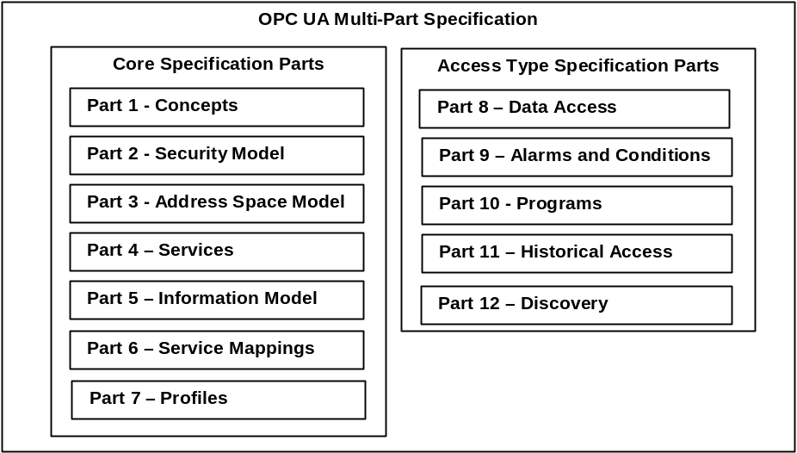
Figure 1 – OPC UA Specification Organization
The first seven parts specify the core capabilities of OPC UA. These core capabilities define the structure of the OPC AddressSpace and the Services that operate on it. Parts 8 through 11 apply these core capabilities to specific types of access previously addressed by separate OPC COM specifications, such as Data Access (DA), Alarms and Events (A&E) and Historical Data Access (HDA). Part 12: describes Discovery mechanisms for OPC UA.
Readers are encouraged to read Parts 1 through 5 of the core specifications before reading Parts 8 through 12. For example, a reader interested in UA Data Access should read Parts 1 through 5 and 8. References in Part 8: may direct the reader to other parts of this specification.

Core Specification Parts
Part 1 – Overview and Concepts
Part 1 (this Part) presents the concepts and overview of OPC UA.
Part 2 – Security Model
Part 2: describes the model for securing interactions between OPC UA Clients and OPC UA Servers.
Part 3 – Address Space Model
Part 3: describes the contents and structure of the Server’s AddressSpace.
Part 4 – Services
Part 4: specifies the Services provided by OPC UA Servers.
Part 5 – Information Model
Part 5: specifies the types and their relationships defined for OPC UA Servers.
Part 6 – Mappings
Part 6 specifies the transport mappings and data encodings supported by OPC UA.
Part 7 – Profiles
Part 7: specifies the Profiles that are available for OPC Clients and Servers. These Profiles provide groups of Services or functionality that can be used for conformance level certification. Servers and Clients will be tested against the Profiles.

Access Type Specification Parts
Part 8 – Data Access
Part 8: specifies the use of OPC UA for data access.
Part 9 – Alarms and Conditions
Part 9: specifies use of OPC UA support for access to Alarms and Conditions. The base system includes support for simple Events; this specification extends that support to include support for Alarms and Conditions.
Part 10 – Programs
Part 10: specifies OPC UA support for access to Programs.
Part 11 – Historical Access
Part 11: specifies use of OPC UA for historical access. This access includes both historical data and historical Events.
Part 12 – Discovery
Part 12: specifies how Discovery Servers operate in different scenarios and describes how UA Clients and Servers should interact with them. It also defines how UA related information should be accessed using common directory service protocols such as UDDI and LDAP.

Overview

UA Scope
OPC UA is applicable to manufacturing software in application areas such as Field Devices, Control Systems, Manufacturing Execution Systems and Enterprise Resource Planning Systems. These systems are intended to exchange information and to use command and control for industrial processes. OPC UA defines a common infrastructure model to facilitate this information exchange OPC UA specifies the following:
- The information model to represent structure, behaviour and semantics.
- The message model to interact between applications.
- The communication model to transfer the data between end-points.
- The conformance model to guarantee interoperability between systems.

Introduction
OPC UA is a platform-independent standard through which various kinds of systems and devices can communicate by sending Messages between Clients and Servers over various types of networks. It supports robust, secure communication that assures the identity of Clients and Servers and resists attacks. OPC UA defines sets of Services that Servers may provide, and individual Servers specify to Clients what Service sets they support. Information is conveyed using OPC UA-defined and vendor-defined data types, and Servers define object models that Clients can dynamically discover. Servers can provide access to both current and historical data, as well as Alarms and Events to notify Clients of important changes. OPC UA can be mapped onto a variety of communication protocols and data can be encoded in various ways to trade off portability and efficiency.

Design goals
OPC UA provides a consistent, integrated AddressSpace and service model. This allows a single OPC UA Server to integrate data, Alarms and Events, and history into its AddressSpace, and to provide access to them using an integrated set of Services. These Services also include an integrated security model.
OPC UA also allows Servers to provide Clients with type definitions for the Objects accessed from the AddressSpace. This allows information models to be used to describe the contents of the AddressSpace. OPC UA allows data to be exposed in many different formats, including binary structures and XML documents. The format of the data may be defined by OPC, other standard organizations or vendors. Through the AddressSpace, Clients can query the Server for the metadata that describes the format for the data. In many cases, Clients with no pre-programmed knowledge of the data formats will be able to determine the formats at runtime and properly utilize the data.
OPC UA adds support for many relationships between Nodes instead of being limited to just a single hierarchy. In this way, an OPC UA Server may present data in a variety of hierarchies tailored to the way a set of Clients would typically like to view the data. This flexibility, combined with support for type definitions, makes OPC UA applicable to a wide array of problem domains. As illustrated below, OPC UA is not targeted at just the SCADA, PLC and DCS interface, but also as a way to provide greater interoperability between higher level functions.
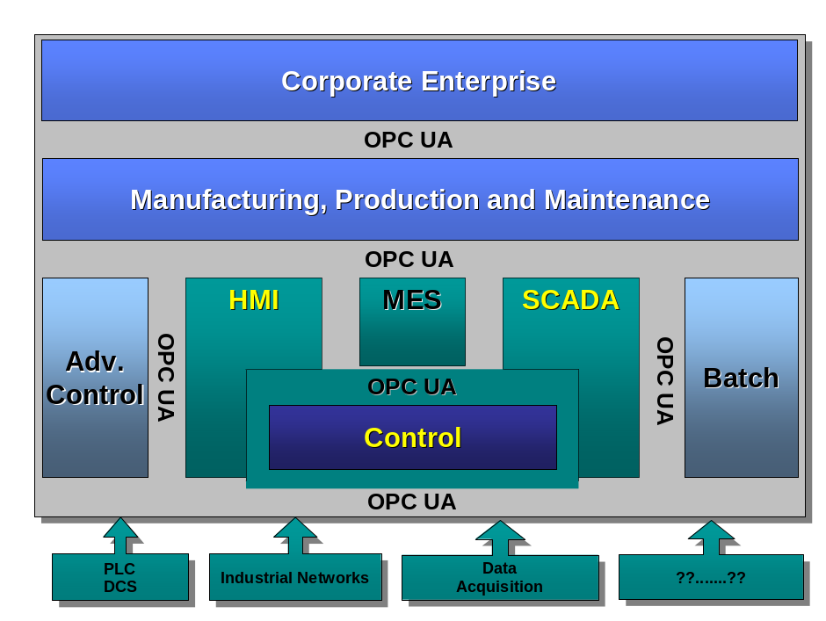
Figure 2 – OPC UA Target Applications
OPC UA is designed to provide robustness of published data. A major feature of all OPC servers is the ability to publish data and Event Notifications. OPC UA provides mechanisms for Clients to quickly detect and recover from communication failures associated with these transfers without having to wait for long timeouts provided by the underlying protocols.
OPC UA is designed to support a wide range of Servers, from plant floor PLCs to enterprise Servers. These Servers are characterized by a broad scope of size, performance, execution platforms and functional capabilities. Therefore, OPC UA defines a comprehensive set of capabilities, and Servers may implement a subset of these capabilities. To promote interoperability, OPC UA defines subsets, referred to as Profiles, to which Servers may claim conformance. Clients can then discover the Profiles of a Server, and tailor their interactions with that Server based on the Profiles. Profiles are defined in Part 7:.
The OPC UA specifications are layered to isolate the core design from the underlying computing technology and network transport. This allows OPC UA to be mapped to future technologies as necessary, without negating the basic design. Mappings and data encodings are described in Part 6. Two data encodings are defined in this part:
- XML/text
- UA Binary
In addition, two transport mappings are defined in this part:
- TCP
- SOAP Web services over HTTP
Clients and Servers that support multiple transports and encodings will allow the end users to make decisions about tradeoffs between performance and XML Web service compatibility at the time of deployment, rather than having these tradeoffs determined by the OPC vendor at the time of product definition.
OPC UA is designed as the migration path for OPC clients and servers that are based on Microsoft COM technology. Care has been taken in the design of OPC-UA so that existing data exposed by OPC COM servers (DA, HDA and A&E) can easily be mapped and exposed via OPC UA. Vendors may choose to migrate their products natively to OPC UA or use external wrappers to convert from OPC COM to OPC UA and vice-versa. Each of the previous OPC specifications defined its own address space model and its own set of Services. OPC UA unifies the previous models into a single integrated address space with a single set of Services.

Integrated models and services

Security model

General
OPC UA security is concerned with the authentication of Clients and Servers, the authentication of users, the integrity and confidentiality of their communications, and the verifiability of claims of functionality. It does not specify the circumstances under which various security mechanisms are required. That specification is crucial, but it is made by the designers of the system at a given site and may be specified by other standards.
Rather, OPC UA provides a security model, defined in Part 2:, in which security measures can be selected and configured to meet the security needs of a given installation. This model includes security mechanisms and parameters. In some cases, the mechanism for exchanging security parameters is defined, but the way that applications use these parameters is not. This framework also defines a minimum set of security Profiles that all UA Servers support, even though they may not be used in all installations. Security Profiles are defined in Part 7:.

Discovery and Session establishment
Application level security relies on a secure communication channel that is active for the duration of the application Session and ensures the integrity of all Messages that are exchanged. This means users need to be authenticated only once, when the application Session is established. The mechanisms for discovering OPC UA Servers and establishing secure communication channels and application Sessions are described in Part 4: and Part 6. Additional information about the Discovery process is described in Part 12:
When a Session is established, the Client and Server applications negotiate a secure communications channel and exchange software Certificates that identify the Client and Server and the capabilities that they provide. Authority-generated software Certificates indicate the OPC UA Profiles that the applications implement and the OPC UA certification level reached for each Profile. The details of each Profile and the Certificates are specified in Part 7:. Certificates issued by other organizations may also be exchanged during Session establishment.
The Server further authenticates the user and authorizes subsequent requests to access Objects in the Server. Authorization mechanisms, such as access control lists, are not specified by the OPC UA specification. They are application or system-specific.

Auditing
OPC UA includes support for security audit trails with traceability between Client and Server audit logs. If a security-related problem is detected at the Server, the associated Client audit log entry can be located and examined. OPC UA also provides the capability for Servers to generate Event Notifications that report auditable Events to Clients capable of processing and logging them. OPC UA defines security audit parameters that can be included in audit log entries and in audit Event Notifications. Part 5: defines the data types for these parameters. Not all Servers and Clients provide all of the auditing features. Profiles, found in Part 7:, indicate which features are supported.

Transport security
OPC UA security complements the security infrastructure provided by most web service capable platforms.
Transport level security can be used to encrypt and sign Messages. Encryption and signatures protect against disclosure of information and protect the integrity of Messages. Encryption capabilities are provided by the underlying communications technology used to exchange Messages between OPC UA applications. Part 7: defines the encryption and signature algorithms to be used for a given Profile.

Integrated AddressSpace model
The set of Objects and related information that the OPC UA Server makes available to Clients is referred to as its AddressSpace. The OPC UA AddressSpace represents its contents as a set of Nodes connected by References.
Primitive characteristics of Nodes are described by OPC-defined Attributes. Attributes are the only elements of a Server that have data values. Data types that define attribute values may be simple or complex.
Nodes in the AddressSpace are typed according to their use and their meaning. NodeClasses define the metadata for the OPC UA AddressSpace. Part 3: defines the OPC UA NodeClasses.
The Base NodeClass defines Attributes common to all Nodes, allowing identification, classification and naming. Each NodeClass inherits these Attributes and may additionally define its own Attributes.
To promote interoperability of Clients and Servers, the OPC UA AddressSpace is structured hierarchically with the top levels the same for all Servers. Although Nodes in the AddressSpace are typically accessible via the hierarchy, they may have References to each other, allowing the AddressSpace to represent an interrelated network of Nodes. The model of the AddressSpace is defined in Part 3:.
OPC UA Servers may subset the AddressSpace into Views to simplify Client access. Clause 6.3.3.3 describes AddressSpace Views in more detail.

Integrated object model
The OPC UA Object Model provides a consistent, integrated set of NodeClasses for representing Objects in the AddressSpace. This model represents Objects in terms of their Variables, Events and Methods, and their relationships with other Objects. Part 3: describes this model.
The OPC UA object model allows Servers to provide type definitions for Objects and their components. Type definitions may be subclassed. They also may be common or they may be system-specific. ObjectTypes may be defined by standards organizations, vendors or end-users.
This model allows data, Alarms and Events, and their history to be integrated into a single OPC UA Server. For example, OPC UA Servers are able to represent a temperature transmitter as an Object that is composed of a temperature value, a set of alarm parameters, and a corresponding set of alarm limits.

Integrated services
The interface between OPC UA Clients and Servers is defined as a set of Services. These Services are organized into logical groupings called Service Sets. Service Sets are discussed in Clause 7 and specified in Part 4:.
OPC UA Services provide two capabilities to Clients. They allow Clients to issue requests to Servers and receive responses from them. They also allow Clients to subscribe to Servers for Notifications. Notifications are used by the Server to report occurrences such as Alarms, data value changes, Events, and Program execution results.
OPC UA Messages may be encoded as XML text or in binary format for efficiency purposes. They may be transferred using multiple underlying transports, for example TCP or web services over HTTP. Servers may provide different encodings and transports as defined by Part 7:.

Sessions
OPC UA requires a stateful model. The state information is maintained inside an application Session. Examples of state-information are Subscriptions, user credentials and continuation points for operations that span multiple requests.
Sessions are defined as logical connections between Clients and Servers. Servers may limit the number of concurrent Sessions based on resource availability, licensing restrictions, or other constraints. Each Session is independent of the underlying communications protocols. Failures of these protocols do not automatically cause the Session to terminate. Sessions terminate based on Client or Server request, or based on inactivity of the Client. The inactivity time interval is negotiated during Session establishment.

Redundancy
The design of OPC UA ensures that vendors can create redundant Clients and redundant Servers in a consistent manner. Redundancy may be used for high availability, fault tolerance and load balancing. The details for redundancy are found in Part 4:. Only some Profiles Part 7: will require redundancy support, but not the base Profile.

Systems concepts

Overview
The OPC UA systems architecture models OPC UA Clients and Servers as interacting partners. Each system may contain multiple Clients and Servers. Each Client may interact concurrently with one or more Servers, and each Server may interact concurrently with one or more Clients. An application may combine Server and Client components to allow interaction with other Servers and Clients as described in Clause 6.3.6.
OPC UA Clients and Servers are described in the clauses that follow. Figure 3 illustrates the architecture that includes a combined Server and Client.
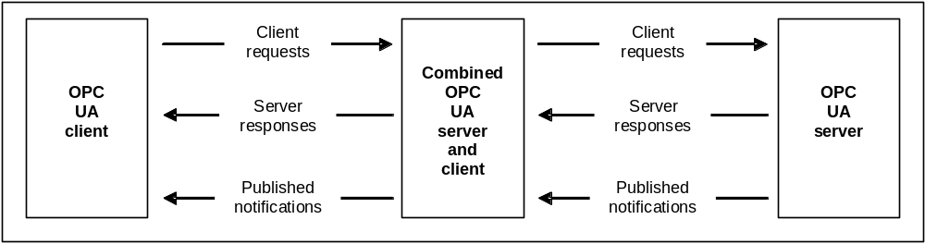
Figure 3 – OPC UA System Architecture

OPC UA Clients
The OPC UA Client architecture models the Client endpoint of client/server interactions. Figure 4 illustrates the major elements of a typical OPC UA Client and how they relate to each other.
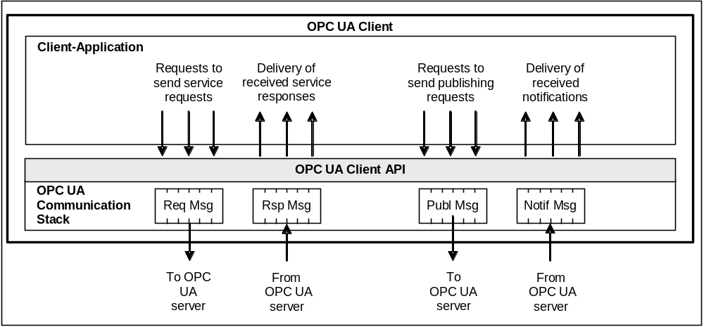
Figure 4 – OPC UA Client Architecture
The Client Application is the code that implements the function of the Client. It uses the OPC UA Client API to send and receive OPC UA Service requests and responses to the OPC UA Server. The Services defined for OPC UA are described in Clause 7, and specified in Part 4:.
Note that the “OPC UA Client API” is an internal interface that isolates the Client application code from an OPC UA Communication Stack. The OPC UA Communication Stack converts OPC UA Client API calls into Messages and sends them through the underlying communications entity to the Server at the request of the Client application. The OPC UA Communication Stack also receives response and NotificationMessages from the underlying communications entity and delivers them to the Client application through the OPC UA Client API.

OPC UA Servers
The OPC UA Server architecture models the Server endpoint of client/server interactions. Figure 5 illustrates the major elements of the OPC UA Server and how they relate to each other.
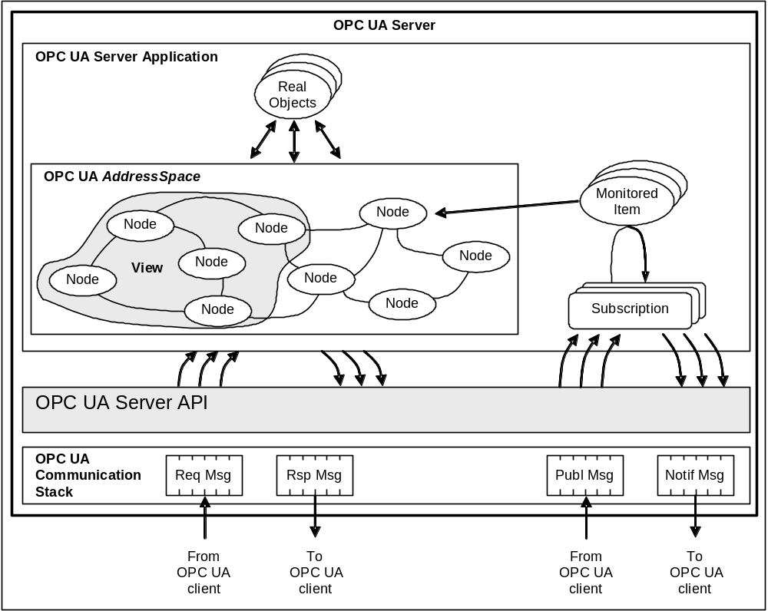
Figure 5 – OPC UA Server Architecture

Real objects
Real objects are physical or software objects that are accessible by the OPC UA Server application or that it maintains internally. Examples include physical devices and diagnostics counters.

OPC UA Server application
The OPC UA Server application is the code that implements the function of the Server. It uses the OPC UA Server API to send and receive OPC UA Messages from OPC UA Clients. Note that the “OPC UA Server API” is an internal interface that isolates the Server application code from an OPC UA Communication Stack.

OPC UA AddressSpace

AddressSpace Nodes
The AddressSpace is modelled as a set of Nodes accessible by Clients using OPC UA Services (interfaces and methods). Nodes in the AddressSpace are used to represent real objects, their definitions and their References to each other.

AddressSpace organization
Part 3: contains the details of the meta model “building blocks” used to create an AddressSpace out of interconnected Nodes in a consistent manner. Servers are free to organize their Nodes within the AddressSpace as they choose. The use of References between Nodes permits Servers to organize the AddressSpace into hierarchies, a full mesh network of Nodes, or any possible mix.
Part 5: defines OPC UA Nodes and References and their expected organization in the AddressSpace. Some Profiles will not require that all of the UA Nodes be implemented.

AddressSpace Views
A View is a subset of the AddressSpace. Views are used to restrict the Nodes that the Server makes visible to the Client, thus restricting the size of the AddressSpace for the Service requests submitted by the Client. The default View is the entire AddressSpace. Servers may optionally define other Views. Views hide some of the Nodes or References in the AddressSpace. Views are visible via the AddressSpace and Clients are able to browse Views to determine their structure. Views are often hierarchies, which are easier for Clients to navigate and represent in a tree.

Support for information models
The OPC UA AddressSpace supports information models. This support is provided through:
- Node References that allow Objects in the AddressSpace to be related to each other.
- ObjectType Nodes that provide semantic information for real Objects (type definitions).
- ObjectType Nodes to support subclassing of type definitions.
- Data type definitions exposed in the AddressSpace that allow industry specific data types to be used.
- OPC UA companion standards that permit industry groups to define how their specific information models are to be represented in OPC UA Server AddressSpaces.

Publisher/subscriber entities

MonitoredItems
MonitoredItems are entities in the Server created by the Client that monitor AddressSpace Nodes and their real-world counterparts. When they detect a data change or an event/alarm occurrence, they generate a Notification that is transferred to the Client by a Subscription.

Subscriptions
A Subscription is an endpoint in the Server that publishes Notifications to Clients. Clients control the rate at which publishing occurs by sending Publish Messages.

OPC UA Service Interface

General
The Services defined for OPC UA are described in Clause 7, and specified in Part 4:.

Request/response Services
Request/response Services are Services invoked by the Client through the OPC UA Service Interface to perform a specific task on one or more Nodes in the AddressSpace and to return a response.

Publisher Services
Publisher Services are Services invoked through the OPC UA Service Interface for the purpose of periodically sending Notifications to Clients. Notifications include Events, Alarms, data changes and Program outputs.

Server to Server interactions
Server to Server interactions are interactions in which one Server acts as a Client of another Server. Server to Server interactions allow for the development of servers that:
- exchange information with each other on a peer-to-peer basis, this could include redundancy or remote Servers that are used for maintaining system wide type definitions(see Figure 6),
- are chained in a layered architecture of Servers to provide:
- aggregation of data from lower-layer Servers,
- higher-layer data constructs to Clients, and
- concentrator interfaces to Clients for single points of access to multiple underlying Servers.
Figure 6 illustrates interactions between Servers.
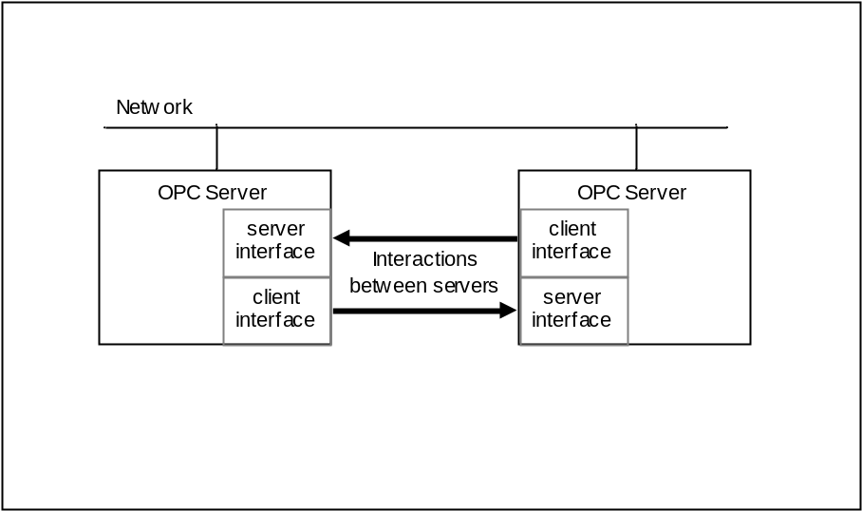
Figure 6 – Peer-to-peer interactions between Servers
Figure 7 extends the previous example and illustrates the chaining of OPC UA Servers together for vertical access to data in an enterprise.
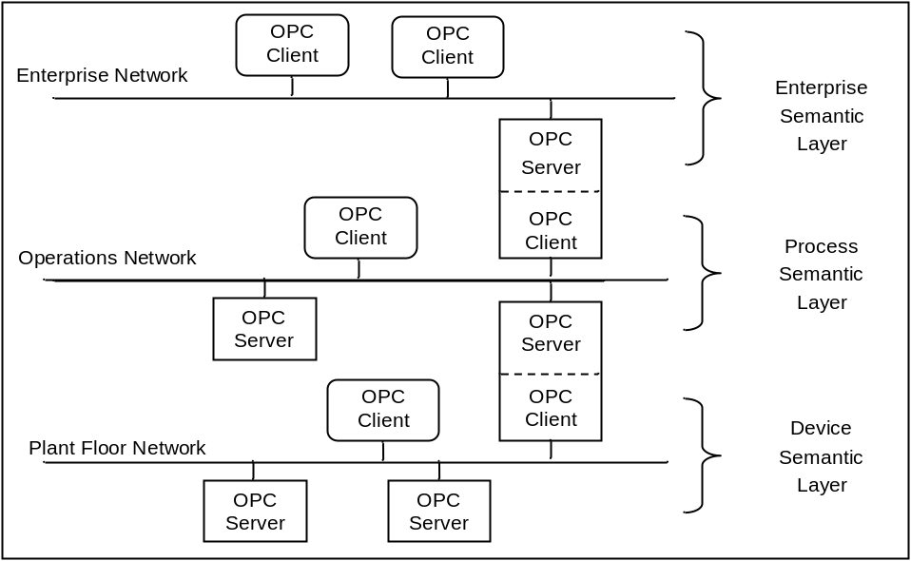
Figure 7 – Chained Server Example

Service Sets

General
OPC UA Services are divided into Service Sets, each defining a logical grouping of Services used to access a particular aspect of the Server. The Service Sets are described below. The Service Sets and their Services are specified in Part 4:. Whether or not a Server supports a Service Set, or a specific Service within a Service Set, is defined by its Profile. Profiles are described in Part 7:.

Discovery Service Set
This Service Set defines Services used to discover OPC UA Servers that are available in a system. It also provides a manner in which clients can read the security configuration required for connection to the Server. The Discovery Services are implemented by individual Servers and by dedicated Discovery Servers. Well known dedicated Discovery Servers provide a way for clients to discover all registered OPC UA Servers. Part 12: describes how to use the Discovery Services with dedicated Discovery Servers.

SecureChannel Service Set
This Service Set defines Services used to open a communication channel that ensures the confidentiality and integrity of all Messages exchanged with the Server. The base concepts for UA security are defined in Part 2:.
The SecureChannel Services are unlike other Services because they are typically not implemented by the UA application directly. Instead, they are provided by the communication stack that the UA application is built on. For example, a UA Server may be built on a SOAP stack that allows applications to establish a SecureChannel using the WS-SecureConversation specification. In these cases, the UA application simply needs to verify that a WS-SecureConversation is active whenever it receives a Message. Part 6 describes how the SecureChannel Services are implemented with different types of communication stacks.
A SecureChannel is a long-running logical connection between a single Client and a single Server. This channel maintains a set of keys that are known only to the Client and Server and that are used to authenticate and encrypt Messages sent across the network. The SecureChannel Services allow the Client and Server to securely negotiate the keys to use.
The exact algorithms used to authenticate and encrypt Messages are described in the security policies for a Server. These policies are exposed via the Discovery Service Set. A Client selects the appropriate endpoint that supports the desired security policy by the Server when it creates a SecureChannel.
When a Client and Server are communicating via a SecureChannel they verify that all incoming Messages have been signed and/or encrypted according to the security policy. A UA application is expected to ignore any Message that does not conform to the security policy for the channel.
A SecureChannel is separate from the UA Application Session; however, a single UA Application Session may only be accessed via a single SecureChannel. This implies that the UA application is able to determine what SecureChannel is associated with each Message. A communication stack that provides a SecureChannel mechanism but that does not allow the application to know what SecureChannel was used for a given Message cannot be used to implement the SecureChannel Service Set.
The relationship between the UA Application Session and the SecureChannel is illustrated in Figure 8. The UA applications use the communication stack to exchange Messages. First, the SecureChannel Services are used to establish a SecureChannel between the two communication stacks, allowing them to exchange Messages in a secure way. Second, the UA applications use the Session Service Set to establish a UA application Session.
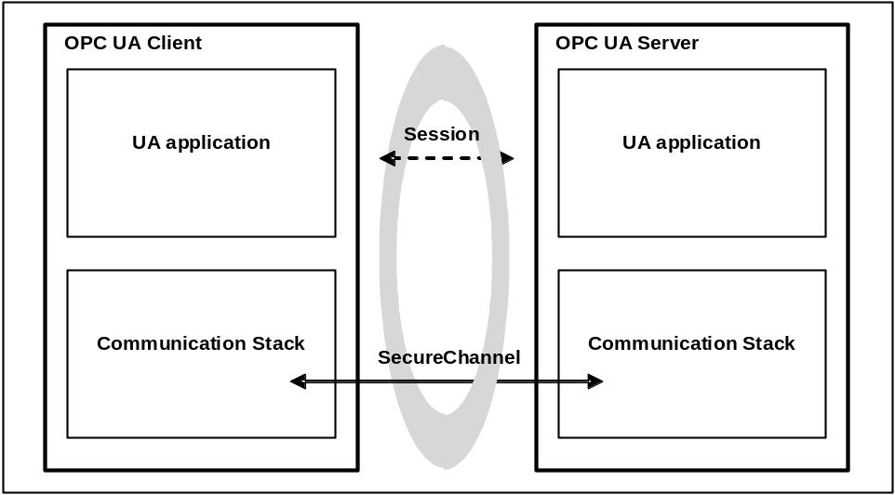
Figure 8 – SecureChannel and Session Services

Session Service Set
This Service Set defines Services used to establish an application-layer connection in the context of a Session on behalf of a specific user.

NodeManagement Service Set
The NodeManagement Service Set allows Clients to add, modify, and delete Nodes in the AddressSpace. These Services provide an interface for the configuration of Servers.

View Service Set
Views are publicly defined, Server-created subsets of the AddressSpace. The entire AddressSpace is the default View, and therefore, the View Services are capable of operating on the entire AddressSpace. Future versions of this specification may also define Services to create Client defined Views.
The View Service Set allows Clients to discover Nodes in a View by browsing. Browsing allows Clients to navigate up and down the hierarchy, or to follow References between Nodes contained in the View. In this manner, browsing also allows Clients to discover the structure of the View.

Query Service Set
The Query Service Set allows users to access the address space without browsing and without knowledge of the logical schema used for internal storage of the data.
Querying allows Clients to select a subset of the Nodes in a View based on some Client-provided filter criteria. The Nodes selected from the View by the query statement are called a result set.
Servers may find it difficult to process queries that require access to runtime data, such as device data, that involves resource intensive operations or significant delays. In these cases, the Server may find it necessary to reject the query.

Attribute Service Set
The Attribute Service Set is used to read and write Attribute values. Attributes are primitive characteristics of Nodes that are defined by OPC UA. They may not be defined by Clients or Servers. Attributes are the only elements in the AddressSpace permitted to have data values. A special Attribute, the Value Attribute is used to define the value of Variables.

Method Service Set
Methods represent the function calls of Objects. They are defined in Part 3:. Methods are invoked and return after completion, whether successful or unsuccessful. Execution times for Methods may vary, depending on the function they are performing.
The Method Service Set defines the means to invoke Methods. A Method is always a component of an Object. Discovery is provided through the browse and query Services. Clients discover the Methods supported by a Server by browsing for the owning Objects that identify their supported Methods.
Because Methods may control some aspect of plant operations, method invocation may depend on environmental or other conditions. This may be especially true when attempting to re-invoke a Method immediately after it has completed execution. Conditions that are required to invoke the Method may not yet have returned to the state that permits the Method to start again. In addition, some Methods may be capable of supporting concurrent invocations, while others may have a single invocation executing at a given time.

MonitoredItem Service Set
The MonitoredItem Service Set is used by the Client to create and maintain MonitoredItems. MonitoredItems monitor Variables, Attributes and EventNotifiers. They generate Notifications when they detect certain conditions. They monitor Variables for a change in value or status; Attributes for a change in value; and EventNotifiers for newly generated Alarm and Event reports.
Each MonitoredItem identifies the item to monitor and the Subscription to use to periodically publish Notifications to the Client (see Clause 7.11). Each MonitoredItem also specifies the rate at which the item is to be monitored (sampled) and, for Variables and EventNotifiers, the filter criteria used to determine when a Notification is to be generated. Filter criteria for Attributes are specified by their Attribute definitions in Part 4:.
The sample rate defined for a MonitoredItem may be faster than the publishing rate of the Subscription. For this reason, the MonitoredItem may be configured to either queue all Notifications or to queue only the latest Notification for transfer by the Subscription. In this latter case, the queue size is one.
MonitoredItem Services also define a monitoring mode. The monitoring mode is configured to disable sampling and reporting, to enable sampling only, or to enable both sampling and reporting. When sampling is enabled, the Server samples the item. In addition, each sample is evaluated to determine if a Notification should be generated. If so, the Notification is queued. If reporting is enabled, the queue is made available to the Subscription for transfer.
Finally, MonitoredItems can be configured to trigger the reporting of other MonitoredItems. In this case, the monitoring mode of the items to report is typically set to sampling only, and when the triggering item generates a Notification, any queued Notifications of the items to report are made available to the Subscription for transfer.

Subscription Service Set
The Subscription Service Set is used by the Client to create and maintain Subscriptions. Subscriptions are entities that periodically publish NotificationMessages for the MonitoredItem assigned to them (see Clause 7.9). The NotificationMessage contains a common header followed by a series of Notifications. The format of Notifications is specific to the type of item being monitored (i.e. Variables, Attributes, and EventNotifiers).
Once created, the existence of a Subscription is independent of the Client’s Session with the Server. This allows one Client to create a Subscription, and a second, possibly a redundant Client, to receive NotificationMessages from it.
To protect against non-use by Clients, Subscriptions have a configured lifetime that Clients periodically renew. If any Client fails to renew the lifetime, the lifetime expires and the Subscription is closed by the Server. When a Subscription is closed, all MonitoredItems assigned to the Subscription are deleted.
Subscriptions include features that support detection and recovery of lost Messages. Each NotificationMessage contains a sequence number that allows Clients to detect missed Messages. When there are no Notifications to send within the keep-alive time interval, the Server sends a keep-alive Message that contains the sequence number of the next NotificationMessage sent. If a Client fails to receive a Message after the keep-alive interval has expired, or if it determines that it has missed a Message, it can request the Server to resend one or more Messages.

The OPC Foundation is an OPC UA Certificate Authority.

